ECONOMICS — CHAPTER 13
THE COSTS OF PRODUCTION

13-1 WHAT ARE COSTS?

13-1a Total Revenue, Total Cost, and Profit
Every firm is in business to MAKE MONEY. The money earned from selling products is Total Revenue. The money spent to make those products is Total Cost. What's left after paying all costs is Profit.

📌 DEFINITION
Total Revenue (TR): The total amount of money a firm receives from selling its output. TR = Price × Quantity Sold.

📌 DEFINITION
Total Cost (TC): The total market value of all inputs (workers, materials, machines, rent) a firm uses to produce its output.

📌 DEFINITION
Profit: What the firm keeps after paying all costs. Profit = Total Revenue − Total Cost.

🧮 FORMULA
Profit = Total Revenue − Total Cost
TR = Price × Quantity
Example: Caroline sells 10,000 cookies @ $2 each → TR = $20,000
If Total Cost = $18,000 → Profit = $20,000 − $18,000 = $2,000

The GOAL of every firm is to MAXIMIZE PROFIT. This is the basic assumption economists make when studying firm behavior.

13-1b Costs as Opportunity Costs
Economists measure cost differently from accountants. For economists, COST means OPPORTUNITY COST — that is, everything you GIVE UP to produce your goods.

Remember the core principle: 'The cost of something is what you give up to get it.' So when a business owner uses her time or money, she gives up other opportunities — and those are real costs too.

📌 DEFINITION
Explicit Costs: Costs that require an ACTUAL CASH PAYMENT from the firm. Example: Paying $1,000 for flour, paying workers' wages.

📌 DEFINITION
Implicit Costs: Costs that do NOT require cash payment but represent foregone opportunities. Example: Caroline is a skilled programmer who could earn $100/hour. Every hour she works in her cookie factory, she loses $100 in potential income — this is an implicit cost.

🌍 REAL LIFE EXAMPLE
Caroline runs a cookie factory. She pays $1,000 for flour (EXPLICIT cost — money leaves her pocket). But she also gave up a $100/hour programming job to run the factory. Even though no money 'leaves', the $100/hour is still a real cost to economists. If her programming salary rises to $500/hour, she may decide cookies aren't worth it and close the factory!

🧠 MEMORY TRICK
EXPLICIT = money you can SEE flowing out (E = Exit of cash)
IMPLICIT = hidden cost you FEEL but don't see (I = Invisible cash flow)
Both are REAL costs to an economist. Only explicit = real to accountant.

13-1c The Cost of Capital as an Opportunity Cost
When you use YOUR OWN MONEY to start a business, you lose the interest you could have earned by saving that money. This lost interest is an IMPLICIT COST.

Example: Caroline used $300,000 of her savings to buy her factory. If she had left that money in a bank at 5% interest, she would earn $15,000 per year. By starting the factory, she gave up $15,000 per year in interest. This is an implicit opportunity cost.

🧮 FORMULA
If Caroline used $100,000 own savings + $200,000 bank loan at 5%:
Explicit cost (bank interest) = $200,000 × 5% = $10,000
Implicit cost (foregone savings interest) = $100,000 × 5% = $5,000
Total Opportunity Cost of Capital = $10,000 + $5,000 = $15,000
Accountant sees only: $10,000 | Economist sees: $15,000

13-1d Economic Profit vs. Accounting Profit
This is one of the most tested concepts in exams! The key difference:

📌 DEFINITION
Accounting Profit: Total Revenue MINUS only Explicit Costs. (What the accountant calculates — the 'official' profit)

📌 DEFINITION
Economic Profit: Total Revenue MINUS ALL Opportunity Costs (both explicit AND implicit). This is what economists care about.

🧮 FORMULA
Accounting Profit = Total Revenue − Explicit Costs
Economic Profit = Total Revenue − (Explicit Costs + Implicit Costs)
Economic Profit = Accounting Profit − Implicit Costs

Since implicit costs are positive, Economic Profit < Accounting Profit (always!)

Type of Profit | Formula | Includes Implicit Costs? | Which is BIGGER?
Accounting Profit | TR − Explicit Costs | NO | Always BIGGER
Economic Profit | TR − (Explicit + Implicit Costs) | YES | Always SMALLER

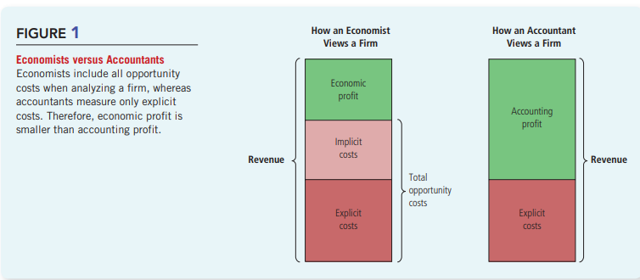

🌍 REAL LIFE EXAMPLE
Farmer McDonald gives banjo lessons for $20/hour. One day he spends 10 hours farming ($100 in seeds, grows $200 in crops). His opportunity cost was 10 hours × $20 = $200 in lost banjo lesson income. Accounting profit = $200 − $100 = $100 (profit!). Economic profit = $200 − $100 − $200 = −$100 (loss!). Even though accountant says profit, the economist says it was a bad decision!

⭐ EXAM IMPORTANT POINTS
➤ Economic profit is ALWAYS less than or equal to accounting profit
➤ A firm with ZERO economic profit is still covering all costs (including implicit) — this is normal/healthy
➤ A firm with NEGATIVE economic profit should consider shutting down in the long run
➤ Accountants IGNORE implicit costs — economists DO NOT
➤ The cost of capital (foregone interest on your own money) is always an implicit cost

❌ COMMON MISTAKE / CONFUSION
✗ Don't confuse: Accounting profit > 0 does NOT mean the firm is doing well economically
✗ Don't forget: If you own the building (no rent payment), there is STILL an implicit cost — the rent you could have earned by renting it out
✗ Explicit costs = cash out of pocket. Implicit costs = value of next-best-alternative given up

⚡ QUICK REVISION
✓ TR = Price × Quantity | Profit = TR − TC
✓ Explicit costs = cash payments | Implicit costs = forgone opportunities
✓ Economic Profit = TR − Explicit − Implicit | Accounting Profit = TR − Explicit
✓ Economic profit is always SMALLER than accounting profit

13-2 PRODUCTION AND COSTS

13-2a The Production Function
A production function shows the RELATIONSHIP between the number of inputs (like workers) and the quantity of output (like cookies) produced. It answers: 'If I hire one more worker, how many more cookies can I make?'

📌 DEFINITION
Production Function: The relationship between the quantity of inputs used to make a good and the quantity of output produced. Example: How many workers → how many cookies per hour.

📌 DEFINITION
Marginal Product of Labor: The EXTRA output produced when ONE MORE unit of input (worker) is added. Formula: Marginal Product = Change in Output ÷ Change in Input.

Here is Caroline's Cookie Factory production table:

Workers | Output (Cookies/Hour) | Marginal Product | Total Cost
0 | 0 | — | $30
1 | 50 | 50 | $40
2 | 90 | 40 | $50
3 | 120 | 30 | $60
4 | 140 | 20 | $70
5 | 150 | 10 | $80
6 | 155 | 5 | $90

NOTICE: As we add more workers, the marginal product DECREASES. The 1st worker adds 50 cookies. The 2nd adds 40. The 3rd adds 30. Each extra worker adds LESS than the one before. This is called DIMINISHING MARGINAL PRODUCT.

📌 DEFINITION
Diminishing Marginal Product: The property that the marginal product of an input FALLS as the quantity of that input INCREASES. As more workers are added to a fixed-size factory, they get in each other's way, share equipment, and become less productive. Each additional worker contributes FEWER extra cookies.

🌍 REAL LIFE EXAMPLE
Imagine a small kitchen (fixed space). 1st cook: makes 50 cookies. 2nd cook: helps, makes 40 more (total 90). 3rd cook: some crowding, makes 30 more (total 120). 4th cook: more crowding, makes 20 more. 5th cook: very crowded, makes only 10 more. Eventually cooks start bumping into each other! This is diminishing marginal product.

🧠 MEMORY TRICK
Think of it like a phone booth: 1st person fits fine. 2nd person is a bit squished. 5th person is barely moving!
More inputs → Less extra output per input → Diminishing Marginal Product
MP goes DOWN as quantity of input goes UP

13-2b From the Production Function to the Total-Cost Curve
Total cost = Factory cost ($30) + Worker cost ($10 per worker). As output goes up, total cost goes up too. The SHAPE of the total cost curve is the mirror image of the production function.

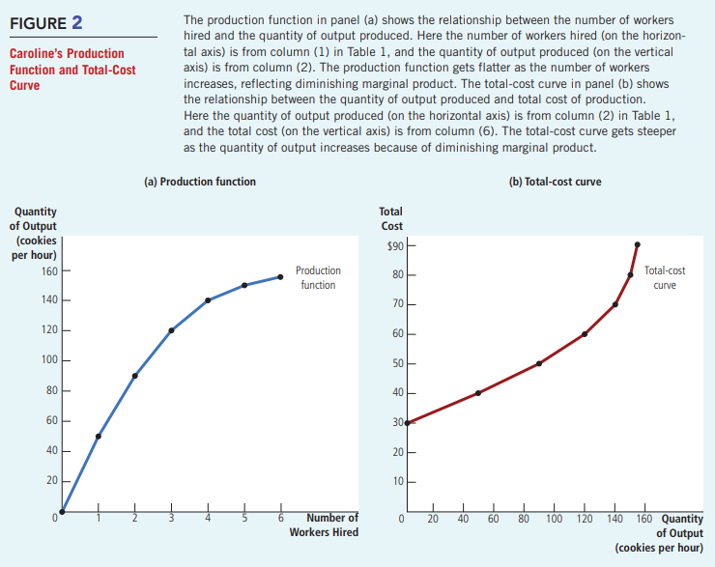

WHY does the total cost curve get steeper? Because of diminishing marginal product! When you need 5 workers to produce the last few cookies instead of just 1 worker for the first 50, the last cookies cost much more to produce.

⭐ EXAM IMPORTANT POINTS
➤ Production Function gets FLATTER as workers increase (due to diminishing MP)
➤ Total Cost Curve gets STEEPER as output increases (same reason)
➤ These two curves are mirror images of each other
➤ Diminishing Marginal Product causes both shapes
➤ Short run = factory size is FIXED. Only workers (variable input) can change.

⚡ QUICK REVISION
✓ Production function = Input (workers) → Output (cookies)
✓ Marginal Product = extra output per extra unit of input
✓ Diminishing Marginal Product: as inputs ↑, extra output per input ↓
✓ Total cost curve is the 'flip side' of the production function

13-3 THE VARIOUS MEASURES OF COST

This is the MOST IMPORTANT section for exams! We will learn 8 types of cost. Don't worry — we'll go through each one slowly and clearly.

We use Conrad's Coffee Shop as our example. Conrad's total cost data is in Table 2.

Output (cups) | Total Cost | Fixed Cost | Variable Cost | AFC | AVC | ATC | Marginal Cost
0 | $3.00 | $3.00 | $0.00 | — | — | — | —
1 | $3.30 | $3.00 | $0.30 | $3.00 | $0.30 | $3.30 | $0.30
2 | $3.80 | $3.00 | $0.80 | $1.50 | $0.40 | $1.90 | $0.50
3 | $4.50 | $3.00 | $1.50 | $1.00 | $0.50 | $1.50 | $0.70
4 | $5.40 | $3.00 | $2.40 | $0.75 | $0.60 | $1.35 | $0.90
5 | $6.50 | $3.00 | $3.50 | $0.60 | $0.70 | $1.30 | $1.10
6 | $7.80 | $3.00 | $4.80 | $0.50 | $0.80 | $1.30 | $1.30
7 | $9.30 | $3.00 | $6.30 | $0.43 | $0.90 | $1.33 | $1.50
8 | $11.00 | $3.00 | $8.00 | $0.38 | $1.00 | $1.38 | $1.70
9 | $12.90 | $3.00 | $9.90 | $0.33 | $1.10 | $1.43 | $1.90
10 | $15.00 | $3.00 | $12.00 | $0.30 | $1.20 | $1.50 | $2.10

13-3a Fixed Costs and Variable Costs
📌 DEFINITION
Fixed Costs (FC): Costs that do NOT change when output changes. They must be paid even if the firm produces NOTHING. Example: Rent of the coffee shop = $3.00. Whether Conrad makes 0 cups or 10 cups, he still pays $3.00 rent.

📌 DEFINITION
Variable Costs (VC): Costs that CHANGE as output changes. When Conrad makes more coffee, he buys more beans, milk, and cups. These costs go UP with output. Variable Cost = 0 when output = 0.

🧮 FORMULA
Total Cost (TC) = Fixed Cost (FC) + Variable Cost (VC)
TC = FC + VC
Example (5 cups): TC = $3.00 (FC) + $3.50 (VC) = $6.50 ✓

Cost Type | Changes with Output? | Zero at Zero Output? | Example
Fixed Cost | NO — stays same | NO — still paid | Rent, machine lease, insurance
Variable Cost | YES — goes up/down | YES — zero at zero | Raw materials, hourly wages, packaging

🌍 REAL LIFE EXAMPLE
A bakery pays $500/month rent (FIXED — doesn't change). It also pays for flour and sugar ($2 per cake made). If it makes 100 cakes, VC = $200. If it makes 200 cakes, VC = $400. The rent stays at $500 either way.

13-3b Average and Marginal Cost
Now we learn 4 more cost types derived from TC, FC, and VC. These are CRUCIAL for understanding firm decisions.

📌 DEFINITION
Average Fixed Cost (AFC): Fixed Cost divided by Quantity produced. AFC = FC ÷ Q. This ALWAYS DECREASES as output increases because the fixed cost is 'spread' over more units.

📌 DEFINITION
Average Variable Cost (AVC): Variable Cost divided by Quantity. AVC = VC ÷ Q. This generally RISES as output increases because of diminishing marginal product.

📌 DEFINITION
Average Total Cost (ATC): Total Cost divided by Quantity. ATC = TC ÷ Q. This is ALSO = AFC + AVC. ATC has a U-SHAPE — first falls, then rises.

📌 DEFINITION
Marginal Cost (MC): The EXTRA cost of producing ONE MORE unit of output. MC = Change in TC ÷ Change in Q. This is the most important cost concept for firm decisions!

🧮 FORMULA
AFC = FC ÷ Q
AVC = VC ÷ Q
ATC = TC ÷ Q (also = AFC + AVC)
MC = ΔTC ÷ ΔQ (change in TC ÷ change in Q)

Example (3 cups): FC=$3.00, VC=$1.50, Q=3
AFC = 3.00÷3 = $1.00 | AVC = 1.50÷3 = $0.50 | ATC = 4.50÷3 = $1.50
MC (from 2 to 3 cups) = (4.50−3.80)÷1 = $0.70

🧠 MEMORY TRICK
TRICK: ATC = AFC + AVC. Always check: do they add up?
MC = cost of the NEXT unit = (new TC − old TC)
Remember: Marginal = 'at the edge' = one more unit
AFC always falls. AVC usually rises. ATC is U-shaped (first falls, then rises).

13-3c Cost Curves and Their Shapes
Now we draw all four cost curves on a graph. This is VERY IMPORTANT for exams. Let's understand each curve's shape.

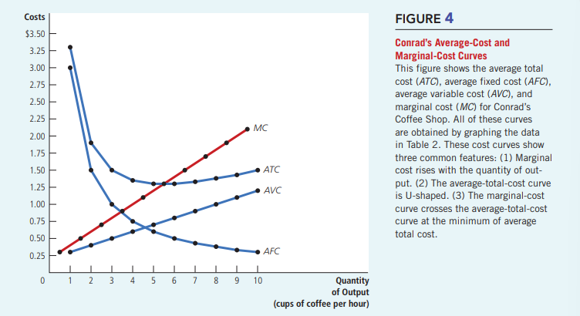

Shape 1: Marginal Cost Curve — Rises with Output
WHY does MC rise? Because of DIMINISHING MARGINAL PRODUCT. When production is low, each extra worker is very productive (lots of idle equipment, space). The extra cost per unit is LOW. But when production is high, workers crowd the facility, productivity drops, and each extra unit becomes MORE expensive to produce.

Shape 2: ATC Curve — U-Shaped
WHY is ATC U-shaped? Because it is the SUM of two opposing forces:
• AFC always FALLS (fixed cost spread over more units → cheaper per unit)
• AVC usually RISES (diminishing marginal product makes each extra unit more expensive)

At low output → AFC is very high (few units to spread cost) → ATC is high. As output rises → AFC falls fast → ATC falls. Eventually → AVC rising force beats AFC falling force → ATC starts rising. The BOTTOM of the U-shape is where ATC is LOWEST.

📌 DEFINITION
Efficient Scale: The quantity of output that minimizes Average Total Cost. This is the BOTTOM of the U-shaped ATC curve. For Conrad's Coffee Shop, efficient scale = 5 or 6 cups per hour (ATC = $1.30).

Shape 3: The KEY Relationship — MC and ATC
This is a critical relationship that is tested VERY OFTEN:

🔑 THE GOLDEN RULE OF MC and ATC:
• When MC < ATC → ATC is FALLING (MC is pulling the average down)
• When MC > ATC → ATC is RISING (MC is pulling the average up)
• When MC = ATC → ATC is at its MINIMUM (the bottom of the U-shape)
• Therefore: MC curve crosses ATC curve at the MINIMUM of ATC

🌍 REAL LIFE EXAMPLE
Think of your GPA (grade point average). If your new grade (marginal grade) is LOWER than your current GPA, your GPA goes DOWN. If your new grade is HIGHER than your GPA, your GPA goes UP. If your new grade EQUALS your GPA, your GPA stays the same. MC and ATC work exactly the same way!

⭐ EXAM IMPORTANT POINTS
➤ MC curve is upward sloping (due to diminishing marginal product)
➤ ATC curve is U-shaped (tug of war between falling AFC and rising AVC)
➤ AFC curve always falls (never rises, never flat)
➤ MC crosses ATC at ATC's MINIMUM point (efficient scale)
➤ MC also crosses AVC at AVC's minimum point
➤ Efficient scale = quantity where ATC is minimized
➤ MC < ATC → ATC falling. MC > ATC → ATC rising. MC = ATC → ATC at minimum.

❌ COMMON MISTAKE / CONFUSION
✗ ATC is NOT always falling — it only falls when MC < ATC, then rises when MC > ATC
✗ MC is NOT the same as ATC — they are different concepts measuring different things
✗ AFC never crosses zero — it just keeps getting smaller and smaller (asymptote)
✗ MC crossing ATC at minimum does NOT mean MC is at its minimum at that point
✗ Don't confuse 'average cost going down' with 'total cost going down' — TC always rises with output

13-3d Typical Cost Curves — With Increasing then Diminishing Marginal Product
In reality, many firms first have INCREASING marginal product (before diminishing sets in). For example, the first few workers can SPECIALIZE and be very efficient. So MC first FALLS, then RISES. This creates an MC curve that is J-shaped (first dips, then rises).

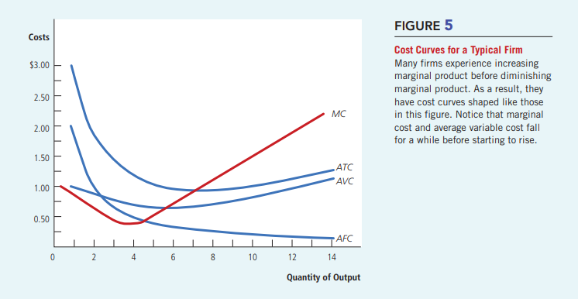

Despite this more complex shape, THREE properties always hold for any firm:
1. Marginal cost EVENTUALLY RISES with output.
2. The Average Total Cost curve is U-SHAPED.
3. The MC curve crosses the ATC curve at the MINIMUM of ATC.

⚡ QUICK REVISION
✓ FC = constant | VC = changes with output | TC = FC + VC
✓ AFC = FC/Q (always falls) | AVC = VC/Q (usually rises) | ATC = TC/Q (U-shaped)
✓ MC = ΔTC/ΔQ (rises, reflects diminishing MP)
✓ MC cuts ATC at ATC's minimum = Efficient Scale
✓ MC < ATC → ATC falls | MC > ATC → ATC rises | MC = ATC → ATC minimum
Cost Type | Symbol | Formula | Behavior as Q ↑
Fixed Cost | FC | Constant | Does not change
Variable Cost | VC | Changes with Q | Always increases
Total Cost | TC | FC + VC | Always increases
Average Fixed Cost | AFC | FC/Q | Always decreases (falls)
Average Variable Cost | AVC | VC/Q | Usually rises (U-ish)
Average Total Cost | ATC | TC/Q = AFC+AVC | U-shaped (falls then rises)
Marginal Cost | MC | ΔTC/ΔQ | Eventually rises; crosses ATC at min

13-4 COSTS IN THE SHORT RUN AND THE LONG RUN

13-4a Short Run vs Long Run Average Total Cost
In the SHORT RUN, some costs are FIXED (like the factory size). In the LONG RUN, ALL costs are VARIABLE — the firm can change EVERYTHING, even factory size.

📌 DEFINITION
Short Run: A time period in which some inputs (like factory size) are FIXED. A firm cannot build a new factory overnight — so it is stuck with what it has.

📌 DEFINITION
Long Run: A time period in which ALL inputs are VARIABLE. The firm can build new factories, close old ones, expand, or shrink however it wants.

Example: Ford Motor Company. In a few months (short run), Ford cannot build new car factories. It can only hire more workers. But over several years (long run), Ford can build new factories or close old ones.

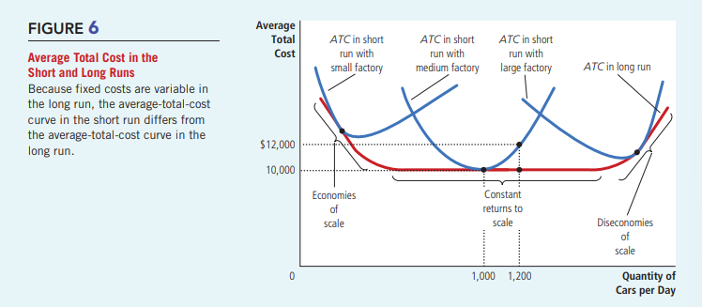

Key insight: Long-run average total cost curve is FLATTER and LOWER than short-run ATC curves because the firm has MORE FLEXIBILITY in the long run. It can always choose the best factory size.

13-4b Economies of Scale, Diseconomies of Scale, and Constant Returns
The SHAPE of the long-run ATC curve tells us about 'returns to scale' — how costs change as firm size grows.

📌 DEFINITION
Economies of Scale: When LONG-RUN AVERAGE TOTAL COST FALLS as output increases. Bigger is cheaper per unit! Usually happens at LOW levels of output. Reason: Specialization — larger firms can divide tasks among workers and use assembly lines, making each worker more productive.

📌 DEFINITION
Diseconomies of Scale: When LONG-RUN AVERAGE TOTAL COST RISES as output increases. Bigger becomes more expensive per unit. Usually happens at HIGH levels of output. Reason: Coordination problems — as firms get very large, management becomes stretched, communication breaks down, and it becomes hard to keep costs down.

📌 DEFINITION
Constant Returns to Scale: When LONG-RUN AVERAGE TOTAL COST STAYS THE SAME as output changes. Neither bigger nor smaller is better per unit. This often occurs at INTERMEDIATE output levels.

Scale Type | What Happens to Long-Run ATC as Q ↑? | Reason | When Does It Occur?
Economies of Scale | ATC FALLS (cheaper per unit) | Specialization, assembly lines, better tech | At LOW output levels
Constant Returns to Scale | ATC STAYS SAME | No advantage or disadvantage to size | At INTERMEDIATE output
Diseconomies of Scale | ATC RISES (more expensive per unit) | Coordination problems, management issues | At HIGH output levels

🌍 REAL LIFE EXAMPLE
A car manufacturer (Ford) at LOW production: Economies of scale — as it builds more cars, it can use assembly lines and specialize workers. Per-car cost falls. At VERY HIGH production: Diseconomies of scale — managing thousands of workers and suppliers becomes chaotic. Per-car cost rises. Somewhere in between: Constant returns to scale.

The book's FYI on Adam Smith's Pin Factory explains this perfectly: In a pin factory, each worker specializes in ONE task (one draws wire, one straightens, one cuts, one points). This specialization allows thousands of pins per day per worker. Without specialization, each worker might make only 20 pins per day. Specialization creates ECONOMIES OF SCALE.

🧮 FORMULA
Example: Boeing makes 9 jets/month at total cost = $9.0 million
If it makes 10 jets/month, total cost = $9.5 million
ATC at 9 jets = $9.0M ÷ 9 = $1.0 million per jet
ATC at 10 jets = $9.5M ÷ 10 = $0.95 million per jet
ATC FELL as output rose → Boeing has ECONOMIES OF SCALE here

⭐ EXAM IMPORTANT POINTS
➤ In SHORT RUN: factory size is fixed (some costs fixed, some variable)
➤ In LONG RUN: ALL costs are variable (even factory size can change)
➤ Long-run ATC is FLATTER and LOWER than any individual short-run ATC
➤ Economies of Scale: Long-run ATC falls as output rises (bigger = cheaper per unit)
➤ Diseconomies of Scale: Long-run ATC rises as output rises (bigger = more expensive per unit)
➤ Constant Returns: Long-run ATC unchanged (size doesn't matter)
➤ Reason for Economies of Scale: SPECIALIZATION of workers
➤ Reason for Diseconomies of Scale: COORDINATION PROBLEMS in large organizations

❌ COMMON MISTAKE / CONFUSION
✗ Economies of scale is about LONG-RUN ATC, NOT short-run ATC
✗ A firm can have BOTH economies AND diseconomies at different output levels (like Ford)
✗ Economies of scale = falling ATC (NOT falling TC — TC always rises with output!)
✗ Don't confuse SHORT RUN (fixed factory) with LONG RUN (all flexible)
✗ Constant returns to scale does NOT mean profits are constant — it means per-unit cost is constant

🧠 MEMORY TRICK
ECONOMIES = Bigger is BETTER (ATC goes DOWN) → 'E for Efficient at larger scale'
DISECONOMIES = Bigger is WORSE (ATC goes UP) → 'DIS means difficult/costly to manage'
CONSTANT = Doesn't matter (ATC stays same)
Short Run = Short clock, stuck with fixed stuff. Long Run = Long time, everything flexible.

⚡ QUICK REVISION
✓ Short run: some inputs fixed (factory size) | Long run: all inputs variable
✓ Long-run ATC lies below all short-run ATC curves (firm picks best factory size)
✓ Economies of Scale: long-run ATC↓ as Q↑ (reason: specialization)
✓ Diseconomies of Scale: long-run ATC↑ as Q↑ (reason: coordination problems)
✓ Constant Returns: long-run ATC unchanged as Q changes

FULL CHAPTER 13 SUMMARY

Topic | Key Ideas
Goal of a firm | Maximize Profit = TR − TC
Total Revenue | Price × Quantity sold
Explicit Costs | Cash payments (visible costs)
Implicit Costs | Foregone opportunities (hidden costs)
Economic Profit | TR − All opportunity costs (explicit + implicit). Always ≤ Accounting Profit.
Accounting Profit | TR − Explicit costs only. Always ≥ Economic Profit.
Production Function | Input (workers) → Output relationship
Marginal Product | Extra output from one more unit of input
Diminishing Marginal Product | As inputs ↑, marginal product ↓. Causes TC curve to get steeper.
Fixed Costs | Don't change with output (rent, insurance)
Variable Costs | Change with output (materials, hourly labor)
TC = FC + VC | Total Cost formula
AFC = FC/Q | Always falls as output rises
AVC = VC/Q | Usually rises (due to diminishing MP)
ATC = TC/Q | U-shaped: falls then rises. Also = AFC + AVC
MC = ΔTC/ΔQ | Extra cost of one more unit. Rises. Crosses ATC at ATC's minimum.
Efficient Scale | Quantity that minimizes ATC (bottom of U-shape)
Short Run | Some inputs fixed (factory). Only variable inputs can change.
Long Run | All inputs variable. Firm can choose factory size.
Economies of Scale | Long-run ATC falls as output rises (specialization)
Diseconomies of Scale | Long-run ATC rises as output rises (coordination problems)
Constant Returns | Long-run ATC unchanged as output changes

⚡ ULTRA SHORT REVISION SHEET

PROFIT = TR − TC | TR = P × Q
Explicit Costs = cash out | Implicit Costs = foregone income/interest
Economic Profit = TR − (Explicit + Implicit) < Accounting Profit = TR − Explicit
Production Function: more workers → more output (but less extra each time = diminishing MP)
Diminishing Marginal Product → TC curve gets steeper as output rises
TC = FC + VC | AFC = FC/Q (↓) | AVC = VC/Q (↑) | ATC = TC/Q (U-shaped)
MC = ΔTC/ΔQ → rises → crosses ATC at ATC's minimum (efficient scale)
If MC < ATC → ATC falls. If MC > ATC → ATC rises. If MC = ATC → ATC at minimum.
Short run = factory fixed | Long run = all inputs flexible
Economies of Scale: Long-run ATC↓ (specialization). Diseconomies: Long-run ATC↑ (coordination problems).

📝 MOST IMPORTANT EXAM QUESTIONS

SHORT QUESTIONS (2-4 marks)
1. What is the difference between explicit costs and implicit costs? Give one example of each.
2. Define economic profit and accounting profit. Which is always larger?
3. What is the law of diminishing marginal product? Give a real-life example.
4. Define fixed cost and variable cost. Give one example of each.
5. What is marginal cost? Write its formula.
6. What is the 'efficient scale' of a firm?
7. Distinguish between short run and long run costs.
8. Define economies of scale and diseconomies of scale.

BROAD/ESSAY QUESTIONS (8-12 marks)
1. Explain the difference between accounting profit and economic profit. Why is economic profit more useful for decision-making? [Use Caroline's Cookie Factory as an example.]
2. Explain the relationship between the production function and the total cost curve. How does diminishing marginal product affect the shape of each?
3. Explain ALL types of costs (FC, VC, TC, AFC, AVC, ATC, MC) with their formulas and behavior as output increases.
4. Draw and explain the average cost and marginal cost curves for a typical firm. Explain the shape of each curve and why MC crosses ATC at the minimum point.
5. Explain how short-run and long-run average total cost differ. What causes the long-run ATC to be flatter and lower than the short-run ATC?

GRAPH QUESTIONS
1. Draw the production function for Caroline's Cookie Factory. Label axes, show the curve getting flatter, and explain why.
2. Draw the total cost curve. Show why it gets steeper. How does it relate to the production function?
3. Draw ATC, AFC, AVC, and MC on ONE graph. Label all key features including the efficient scale.
4. Draw the long-run ATC curve showing economies of scale, constant returns, and diseconomies of scale. Show 3 short-run ATC curves on the same graph.

ANALYTICAL / APPLICATION QUESTIONS
1. Your aunt wants to open a hardware store. It costs $500,000/year in rent and stock. She must quit her $50,000/year accounting job. Her expected revenue is $510,000. Should she open the store? [Calculate both accounting and economic profit.]
2. Conrad's Coffee Shop: Calculate ATC, AFC, AVC, and MC for 5 cups if TC=$6.50, FC=$3.00, VC=$3.50. What is the marginal cost going from 4 to 5 cups if TC at 4 cups = $5.40?
3. A firm has long-run total cost of $60 at Q=1, $70 at Q=2, $80 at Q=3. Does this firm show economies of scale, diseconomies of scale, or constant returns to scale?

🎯 COMMON MCQ CONCEPTS & TRAPS

MCQ Trap / Concept | Correct Answer
Which is BIGGER — economic or accounting profit? | ACCOUNTING profit is always bigger (ignores implicit costs)
As output rises, which cost always falls? | AFC (Average Fixed Cost) — always falls
Where does MC cross ATC? | At the MINIMUM of ATC (efficient scale)
If MC < ATC, what happens to ATC? | ATC FALLS (MC is pulling it down)
What causes diminishing marginal product? | Crowding in a fixed-size factory; workers become less productive
What does the production function's flatter slope mean? | Diminishing marginal product — each extra worker adds less output
What does economies of scale mean? | Long-run ATC FALLS as output rises (NOT short-run ATC)
A $300 license fee on restaurants shifts which curves? | ATC and AFC (it's a fixed cost — adds to FC, not VC)
A $1 per unit tax shifts which curves? | AVC, ATC, and MC (it's a variable cost — changes with output)
Short run vs. long run: which has more fixed costs? | SHORT RUN has fixed costs. Long run: all costs are variable.
What causes diseconomies of scale? | COORDINATION PROBLEMS in large organizations
Xavier sells lemonade for $60, spends $10, foregoes $40 (mowing). Accounting profit? | $60 − $10 = $50. Economic profit = $50 − $40 = $10.

📊 KEY FORMULAS — QUICK REFERENCE

🧮 FORMULA
Profit = TR − TC
TR = Price × Quantity
TC = FC + VC
AFC = FC ÷ Q (always falls)
AVC = VC ÷ Q (usually rises)
ATC = TC ÷ Q = AFC + AVC (U-shaped)
MC = ΔTC ÷ ΔQ (rises; crosses ATC at its minimum)
Economic Profit = TR − Explicit Costs − Implicit Costs
Accounting Profit = TR − Explicit Costs
Economic Profit = Accounting Profit − Implicit Costs
Marginal Product = ΔOutput ÷ ΔInput

